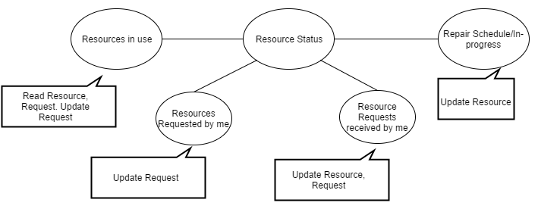

# **Abstract Code w/ SQL- Resource Status**

# **Resources in use**

//application provides $Username of current user

//showing resources in use

SELECT R.Res_ID, R.Res_name, I.Description, R.Username, RE.Start_date, RE.Return_by

FROM RESOURCES AS R INNER JOIN REQUEST AS RE ON R.Res_ID = RE.Res_ID INNER JOIN

INCIDENT AS I ON I.Inc_ID = RE.Inc_ID

Where I.Username = $Username AND R.Status = “in use”

SORT BY R.Res_ID

If ***Return*** button is pressed, then do the following: Update resource;

for each $Status

UPDATE RESOURCES AS R

SET R.Status = “available”

WHERE R.Res_ID = $Res_ID

# **Resources requested by me**

//application provides $Username of current user

//showing resources requested by me

SELECT R.Res_ID, R.Res_name, I.Description, R.Username, RE.Return_by

FROM RESOURCES AS R INNER JOIN REQUEST AS RE ON R.Res_ID = RE.Res_ID INNER JOIN

INCIDENT AS I ON I.Inc_ID = RE.Inc_ID

WHERE I.Username = $Username AND R.Status != “in use”

SORT BY R.Res_ID

If ***Cancel*** button is pressed, then do the following: cancel request;

for each $Status

DELETE FROM REQUEST

WHERE REQUEST.Res_ID = $Res_ID

# **Resources Requests received by me**

//application provides $Username of current user

//showing resources received by me

SELECT R.Res_ID, R.Res_name, I.Description, R.Username, RE.Return_by

FROM RESOURCES AS R INNER JOIN REQUEST AS RE ON R.Res_ID = RE.Res_ID INNER JOIN

INCIDENT AS I ON I.Inc_ID = RE.Inc_ID

WHERE R.Username = $Username

SORT BY RE.Return_by

If ***Deploy*** button is pressed, then do the following: Update resource;

for each $Status

UPDATE RESOURCES AS R

SET R.Status = “in use”

WHERE R.Res_ID = $Res_ID

If ***Reject*** button is pressed, then do the following:Cancel request;

for each $Res_ID

DELETE FROM REQUEST

WHERE REQUEST.Res_ID = $Res_ID

# **Repairs Schedule/ In-Progress**

//application provides $Username of current user

//showing repairs schedule/In-process

SELECT R.Res_ID, R.Res_name, R.Rep_start, R.Rep_ready

FROM RESOURCES AS R

WHERE R.Username = $Username AND R.Status = “in repair”

If ***Cancel*** button is pressed, then do the following: Cancel request;

for each $Status

UPDATE RESOURCES AS R

SET R.Status = “available”

WHERE R.Res_ID = $Res_ID